IOC FILE CONFIGURATION

* MOST OF THE CONFIGURATION IS SIMILAR TO THE CONFIGURATION WE MADE ON THE STM32F469 (<https://github.com/ARM-Mbed/STM32F469_Discover_kit/blob/develop/IOC%20FILE%20CONFIGURATION.pdf>)
* WE CAN SEE NOW HOW RENAME THE GPIO PINS ON THE ‘STM32F407VGTxLQFP100’, SELECTING THOSE PINS AS GPIO OUTPUT

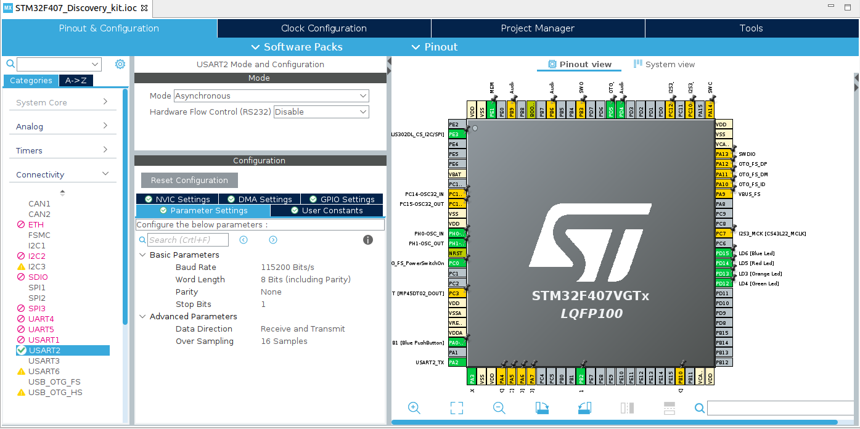

* USART CONFIGURATION ENABLE THE DMA INTERRUPT

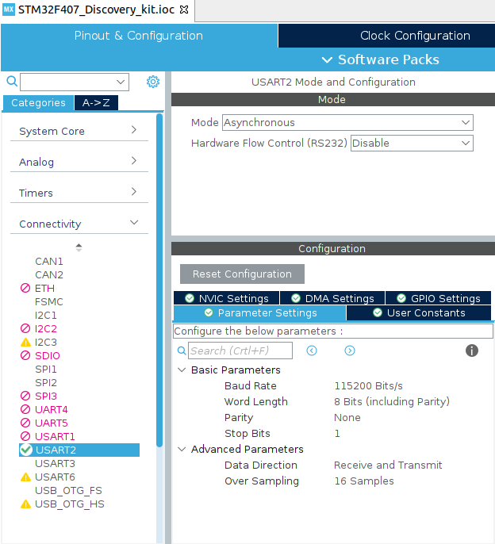

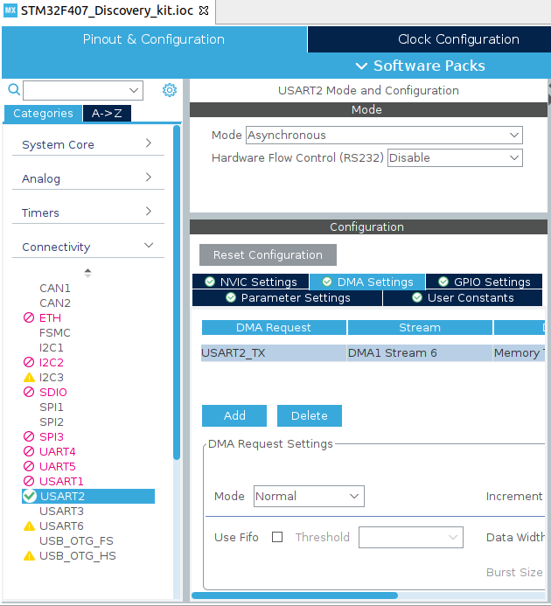

* ADC CONFIGURATION

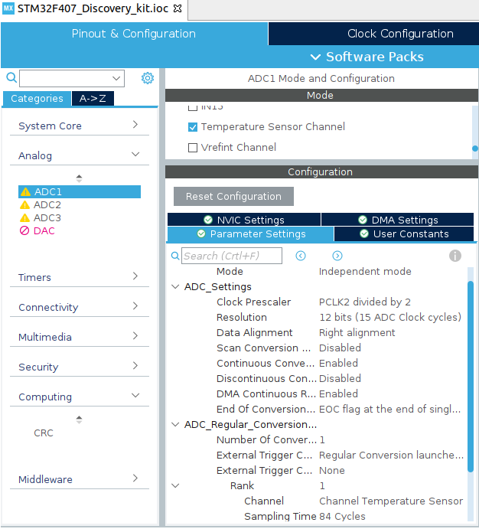

* AND FINALLY WE CAN SEE HOW LOOKS LIKE THE CLOCK CONFIG AND THE PROJECT MANAGER, AFTER THIS SAVE OR GENERATE THE CODE OF THE PROJECT

